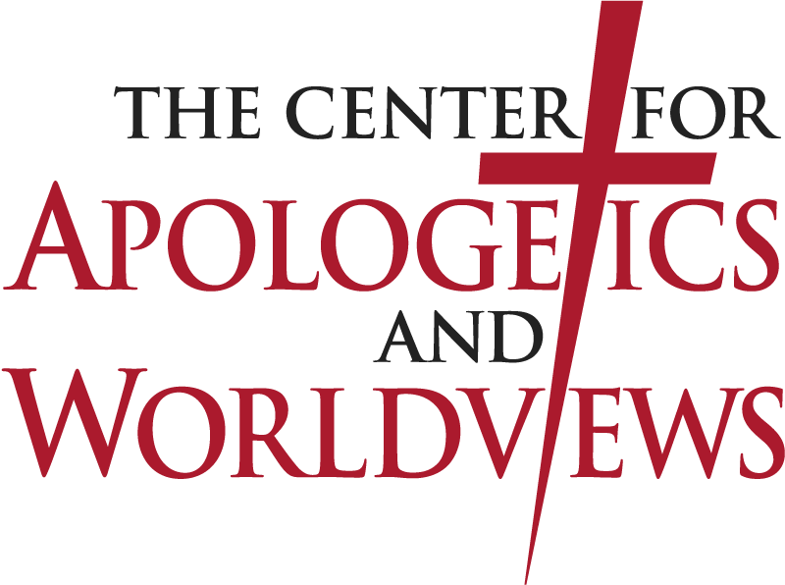
The Sixth Annual Apologetics and Worldview Conference

June 20, 2024

Bethany Lutheran College Mankato, MN

Defending the Gospel of God
The Apologetics of Jesus, Paul, and the Historical Reliability of the New Testament Records

Free Admission

Schedule
- 10:00 a.m. – “Defending the Historical Reliability of the Gospels” – Dr. Adam Francisco, LCMS
- 12:30 p.m. – “Understanding and Applying the Apologetics of Paul” – Prof. Luke Thompson, Martin Luther College, WELS
- 2:00 p.m. – “Understanding and Applying the Apologetics of Jesus” – Rev. David Thompson, Center for Apologetics and Worldviews, ELS
- 3:30 p.m. – Table Talk with presenters

For more information contact Rev. David Thompson
507-344-7395 apologetics@blc.edu
www.apologeticscenter.org

About the Center
The Center for Apologetics and Worldviews (CAW), under the supervision of the Evangelical Lutheran Synod and its Board on Apologetics, promotes evidence for the truth of Christianity and identifies and critiques worldviews at odds with the Christian worldview. We do so to fortify Christians in biblical truth and prepare them to defend the truth—with gentleness and respect—so Christ may be shared wisely and boldly in these post-Christian days.

The Sixth Annual Apologetics and Worldview Conference

June 20, 2024

Bethany Lutheran College Mankato, MN

Defending the Gospel of God
The Apologetics of Jesus, Paul, and the Historical Reliability of the New Testament Records

Free Admission

Schedule
- 10:00 a.m. – “Defending the Historical Reliability of the Gospels” – Dr. Adam Francisco, LCMS
- 12:30 p.m. – “Understanding and Applying the Apologetics of Paul” – Prof. Luke Thompson, Martin Luther College, WELS
- 2:00 p.m. – “Understanding and Applying the Apologetics of Jesus” – Rev. David Thompson, Center for Apologetics and Worldviews, ELS
- 3:30 p.m. – Table Talk with presenters

For more information contact Rev. David Thompson
507-344-7395 apologetics@blc.edu
www.apologeticscenter.org

About the Center
The Center for Apologetics and Worldviews (CAW), under the supervision of the Evangelical Lutheran Synod and its Board on Apologetics, promotes evidence for the truth of Christianity and identifies and critiques worldviews at odds with the Christian worldview. We do so to fortify Christians in biblical truth and prepare them to defend the truth—with gentleness and respect—so Christ may be shared wisely and boldly in these post-Christian days.

